Best Practices for elevator usage

Purpose
In our continued mission to keep everyone safe and supplement our housekeeping staff’s sanitizing efforts we will be placing Napkins/Tissues at all elevators for use when touching the elevator buttons.

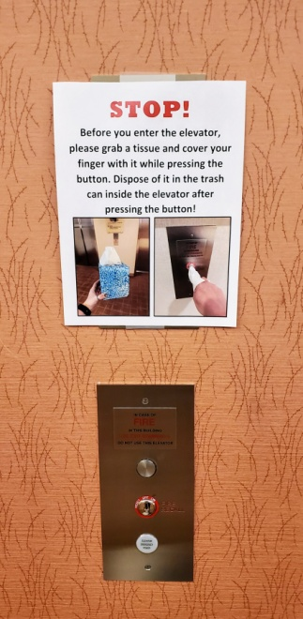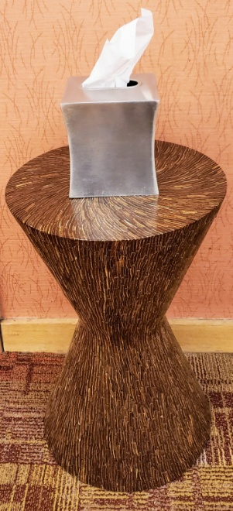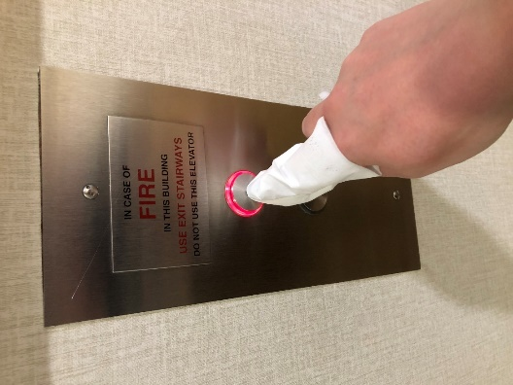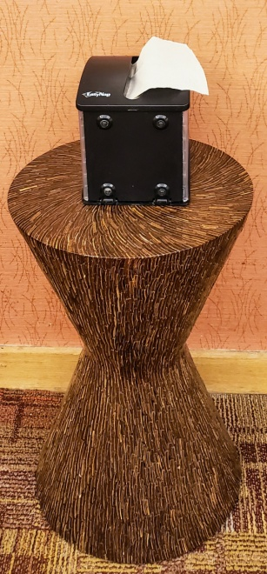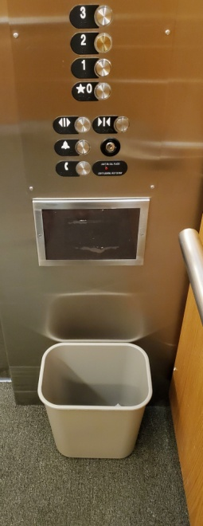

Supplies
- Small Table
- Napkin/Tissue Dispensers
- Napkins/tissues
- Trash Can with Plastic Bag
- Signage

Set-Up for Outside of Elevators
Place a small table with a napkin/tissue dispenser in front of each elevator or elevator bank.
Place the attached sign above the call button panel and on each elevator door.

Set-Up for Inside of Elevators
Place a small trash can under the button panel.
Place a sign reminding users to throw napkins/tissues in trash cans.

Housekeeping
Restock napkins/tissues and empty trash cans throughout the day.
Continue to have Housekeeping clean and disinfect elevator panels.

