Hebrew SeniorLife
Independent and Assisted Living
MAINTENANCE ENTRY PROTOCOL
- Routine maintenance is NOT recommended
- Assess if really necessary, i.e. poses a safety issue
- If maintenance is required
  - Wash hands with soap and water before/when entering the apartment/unit.
  - Bring your own bottled soap and paper towels (may be necessary)
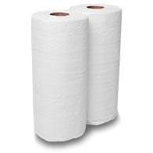
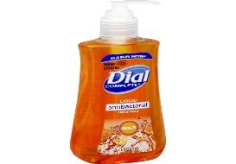
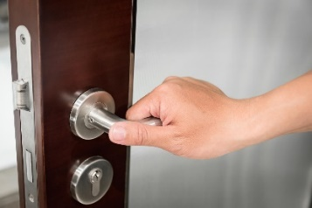
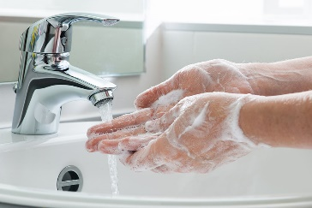

- See YouTube on handwashing (educational forum)
- Wear a disposable yellow mask while in the apartment
- Avoid touching your face at all times
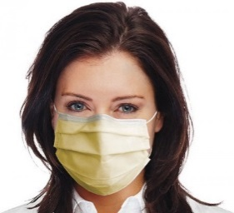
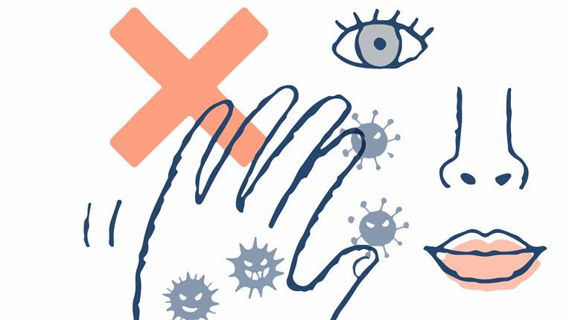
- Gowns are not necessary

GENERAL PROTOCOL
- When in public areas/halls keep a distance of 6 feet way (same as three shopping carts) from residents, staff and other personnel.
- Do not take items from one apartment to another. If you need to do so, be sure to wipe them down with a disinfecting wipe
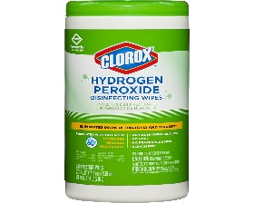
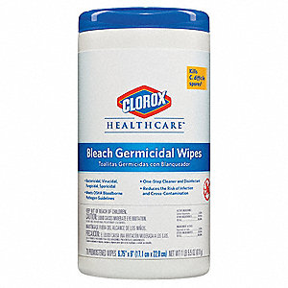
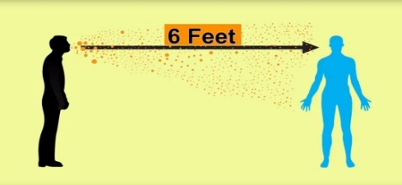

- Discard any packaging in the trash inside resident’s apartment, wash hands immediately.
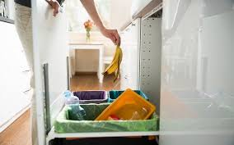
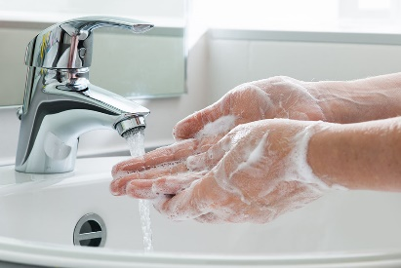

- Whenever possible, use your elbows to push elevator buttons and door handles
We appreciate how hard you are working!
