Hebrew SeniorLife
Independent and Assisted Living

Best Practices for Resident deliveries & Unit Entry

We need your help! You are critical in making sure that the virus does not spread since you are in contact with so many residents. All meals, supplies, groceries and package deliveries will be brought to residents by HSL staff.

Receiving Items From Outside:
All food, supplies, groceries and packages are being delivered to resident apartments/units by HSL Staff
- Screener / Checkpoint staff:
- Wash or disinfect hands before and after touching any delivered item.
- If dropped off by a family member, aide, or delivery person, obtain the name of the person making the delivery, their relation and the resident who is receiving the supplies and/or package.
- Screen the person dropping off the delivery.
- Complete package log.
- Ask what items are included. Is the delivery perishable?
- All packages are to be collected from the vestibule or outside the building and brought to a designated location. Follow site specific sanitation protocol.
- Put on a pair of gloves
- Disinfect item either directly with spray bottle on a paper towel or with a disinfectant wipe. This should be done even if delivery is in a paper bag. Let package stand until dry, approximately three minutes.
- Contact delivery designee or CNA for delivery of perishable items.
- Non-perishable deliveries should be made twice daily to minimize trips and exposure.
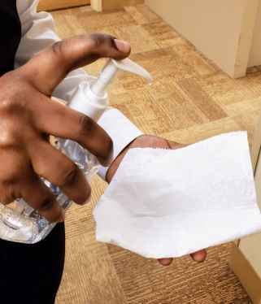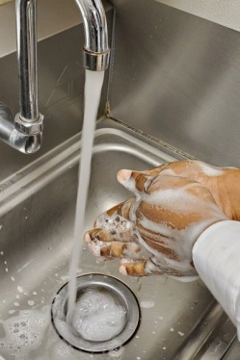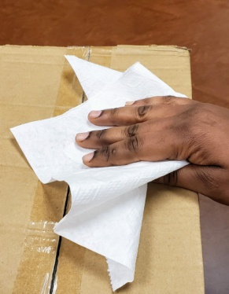

No Entry Delivery:
Whenever possible, leave deliveries outside resident’s door.
- Inform the resident when you are coming.
- Knock on the door.
- Inform resident of the following:
- You are leaving food or delivery outside their door.
- Resident can bring the food or package inside, keeping a safe distance of six feet.
- Resident can discard the plastic bag/cardboard boxes in their trash.
- Resident to wash their hands with soap and water after opening package.

Entering & Exiting A Unit For Residents Who Need Assistance With Delivery:

- Before entering an apartment ask the resident – From the Doorway – if they have a cough, fever, sore throat or shortness of breath. If they answer “Yes”, Do Not Enter. Instead, go to the Front Desk and check in with manager/screener for further instructions.
- Wear a disposable yellow mask before entering the apartment.
- Wipe outside door handle with disinfectant using gloves and open door with disinfectant cloth to enter unit. Pivot with your back to open the door avoiding touching surfaces with exposed skin.
- Bring supplies or food into unit and place on resident’s counter.
- If possible; disinfect faucet handle and wash hands with soap and water. Bring your own soap if necessary (HSL will provide).
- Wear gloves when assisting with meals.
- Avoid touching your face at all times.
- Gowns are not necessary. Contact your manager if other PPE is needed.
- Discard the plastic bag/cardboard boxes in the trash and then wash hands.
- Wipe inside door handle with disinfectant and open door with cloth to exit the unit.

Note: Room service delivery done with another staff member can use the “Buddy System”. One staff member can disinfectant and open doors, and one person can handle only food trays.

