Handwashing and Personal Protective Equipment (PPE) Protocol
for staff/volunteers in housing sites
Updated 4/7/20

You are critical to the safety and well-being of the residents, staff, and volunteers and one of the most important people in making sure that the virus does not spread. You must review this protocol prior to your first shift and please adhere to it whenever you are on-site.

Handwashing
Wash your hands with soap and water for 20 seconds while rubbing vigorously (sing the Happy Birthday song twice) before donning your PPE (Personal Protective Equipment). Wash fronts and backs of your hands, thumbs, wrists, and in-between fingers. If hand washing is not possible, use hand sanitizer as an alternative. Wash your hands frequently and thoroughly throughout the day and between glove changes.
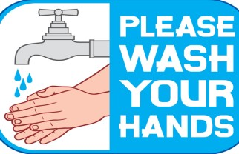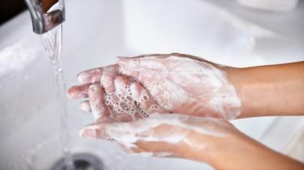

Put on clean gloves. When sanitizing and handling packages and making deliveries, gloves may be re-used for more than one package/delivery as directed by your on-site administration. Never touch gloves to face, doorknobs, and elevator buttons. Gloves should be removed prior to restroom use, meals, or if they are damaged/visibly soiled. Immediately wash hands after removal of gloves. See “How to Remove Gloves PDF” at the end of this document for proper procedures.

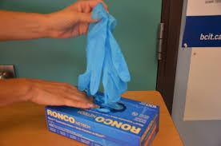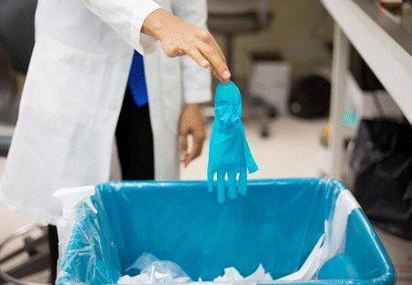

Using a Mask
Pick up the mask carefully by the edges, and apply over your face, including nose and mouth, press around top of the nose for the best fit and apply loops over the ears. Be careful not to touch the front or inside of your mask to keep it as clean as possible. This mask should remain on all day and at end of the day stored for you to re-use on another day (see removal and storage instructions on page 2 of this document). You will be given a new brown paper bag to label with your name, date/time of issuance to prevent reuse by another individual and for safekeeping. If at any time mask is deformed, moist or contaminated, it should be discarded and a new one applied. Avoid touching your face or the mask throughout the day.

To remove mask, take off gloves, clean hands thoroughly with soap and warm water (see handwashing procedure above), grasp the elastic loops of the mask behind your ears and remove the mask. Avoid touching the inside or outside of the mask. If at any time mask is deformed, moist or contaminated, it should be discarded and a new one acquired.

To store mask, place mask in previously labeled paper bag, face mask going in first, then elastic loops. Be careful not to crumple or crush. Wash your hands. Remember to keep the paper bag with mask in a safe and protected place.

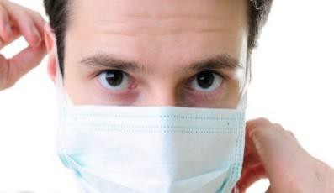

Best Practices
Whenever possible use your elbows (or tissues provided at elevator banks and next to doors) to push elevator buttons and door handles. You may also use a paper towel or the end of your sleeve. Avoid using gloves for doorknobs/elevator buttons.
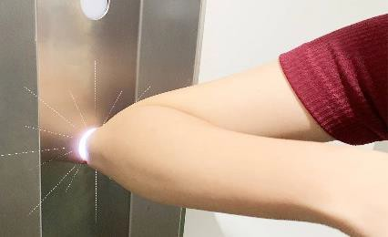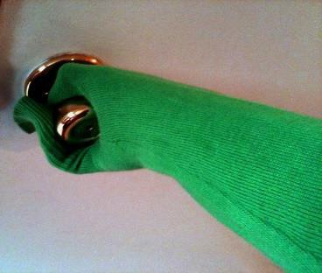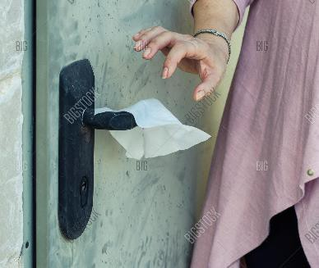

When in public areas/halls keep a minimal distance of 6 feet away (picture length of two shopping carts) from other people.
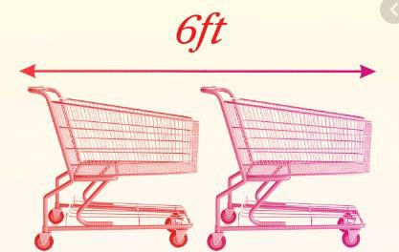

* If you are a clinical worker, please request clinical version of this handout.
We appreciate how hard you are working to serve our seniors!

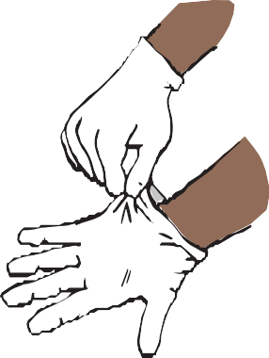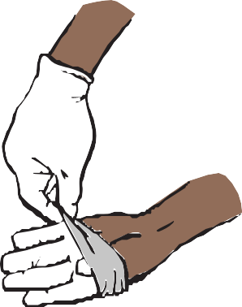
1
2

Grasp the outside of one glove at the wrist.
Do not touch your bare skin.
Peel the glove away from your body, pulling it inside out.

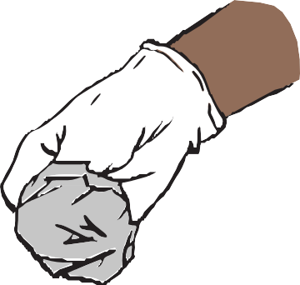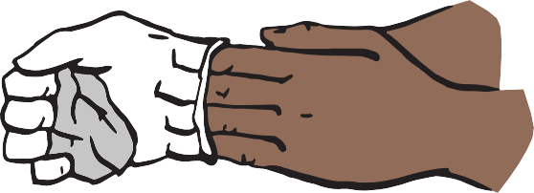
3
4

Hold the glove you just removed in your gloved hand.
Peel off the second glove by putting your fingers inside the glove at the top of your wrist.

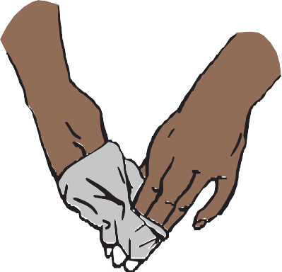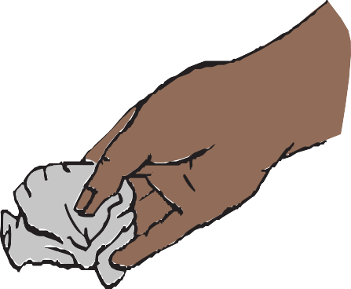
5
6

Turn the second glove inside out while pulling it away from your body, leaving the first glove inside the second.
Dispose of the gloves safely. Do not reuse the gloves.

How to Remove Gloves
To protect yourself, use the following steps to take off gloves

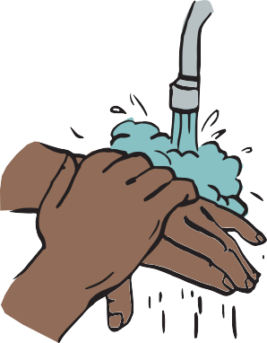
7

Clean your hands immediately after removing gloves.

